# **Dropdown**

Mobile & Desktop Display

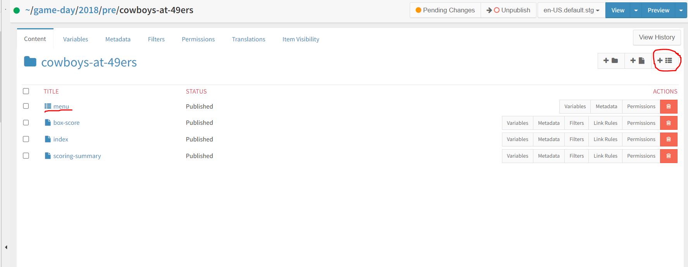

How to Use:

* Create a menu in VSM
  + Add Menu Item
  + For the item that shows when the dropdown has not been opened, type in Text only
  + For each item displayed when the dropdown is opened, add a new Menu item below. Add text and link within the Menu item. Repeat until menu is configured

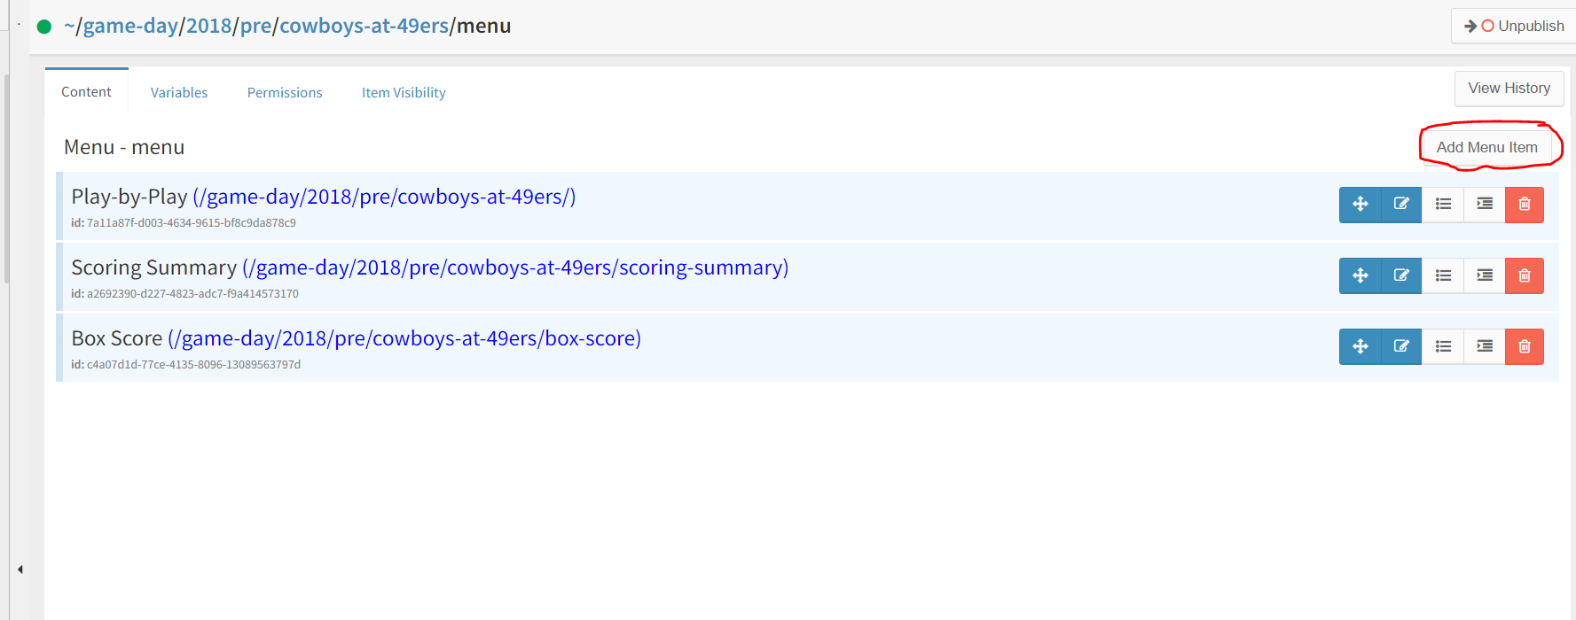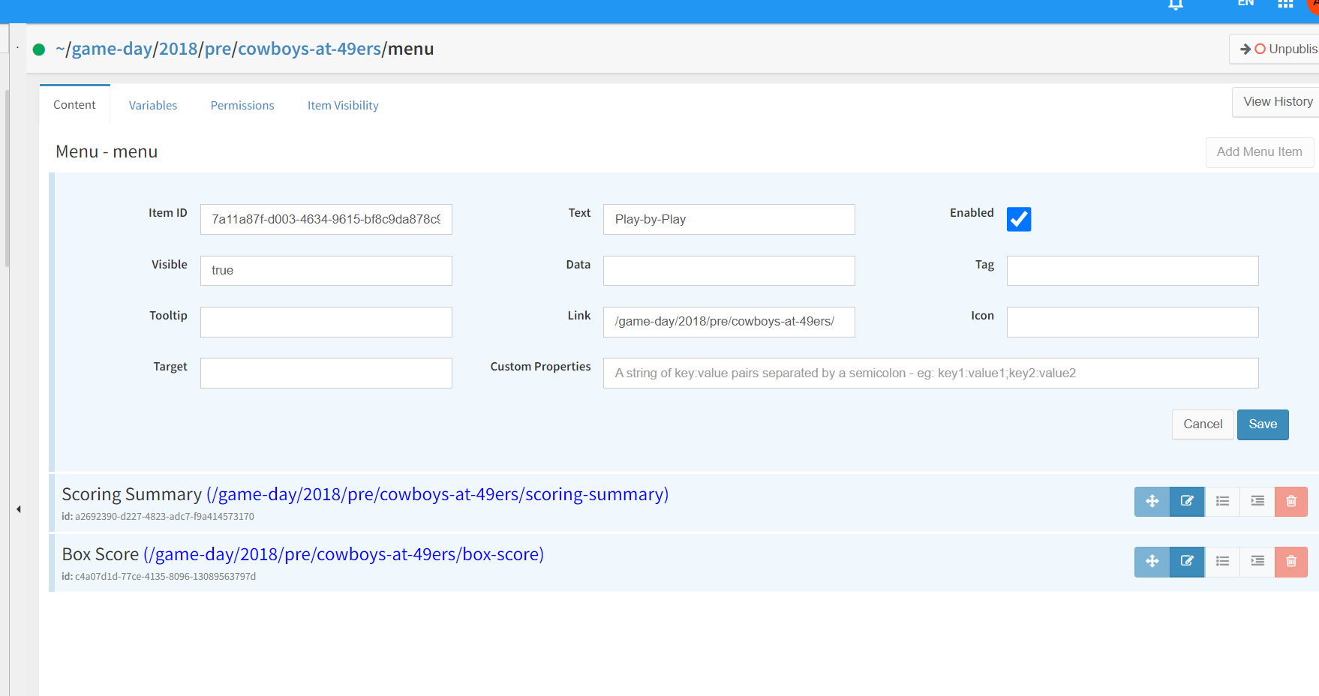

* On page, add Dropdown Component. Add menu path in DropdownFile Field  
  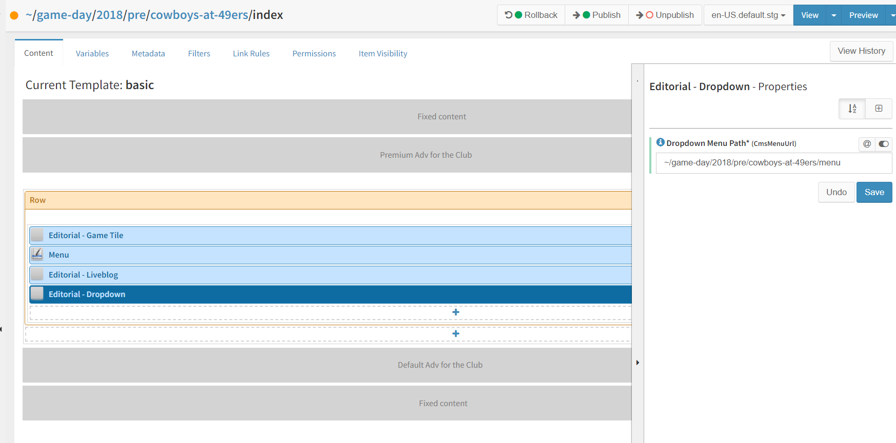

Known Issues:

* N/A